**Notice of Change in CREATE TABLE Query**

We have made a modification to the CREATE TABLE query in our database schema. Instead of using the BY column to store the name of the user who created a comment, we are now using username. This change is made to improve clarity and align with common naming conventions.

**Updated “CREATE TABLE” QUERY:**



**Steps:**

1. Ensure that MySQL is installed.
2. Create Database ‘common_api_pert_telecom_solutions’ in MySQL.



1. Ensure that the MySQL server is running on localhost at port 3306 (or the port specified in mydatabase.port). Update the username and password accordingly.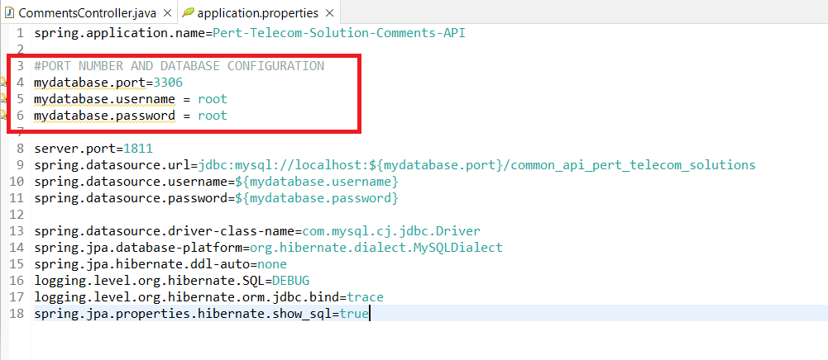
2. Then, run mvn clean install and start the Spring Boot application.
3. The application will be running on port 1811 as configured in the application.properties file. After the application starts, you can access it at:  
   <http://localhost:1811>
4. Use tools like Postman to test the RESTful endpoints provided by the Comments API.